18th September 2019

**Muller’s strong performance boosts title chances at FIA WTCR**

The FIA World Touring Car Cup which has the Japanese premium tyre manufacturer YOKOHAMA as exclusive tyre supplier, promised excitement at the race weekend held in China and it did not disappoint.

After winning Race 1 on Saturday, the veteran Cyan Racing-run Muller beat nephew and fellow Lynk & Co-powered driver Yann Ehrlacher to the victory in Race 3. By finishing third in Race 2, Muller set a record for the most points scored in a single WTCR weekend with an impressive haul of 76. He’s one point down on Esteban Guerrieri (ALL-INKL.COM Münnich Motorsport) and 17 behind new leader Norbert Michelisz (BRC Hyundai N Squadra Corse).

Team Mulsanne’s home favourite Ma Qinghua finished second to Muller in Race 1 but was denied a shot at more success on Sunday. After going fastest in Second Qualifying Q1, Ma was on a flying lap nearing the end of Q2 when he encountered a visibly slower Néstor Girolami.

Anxious not to lose time, Ma attempted to pass at the chicane only for Girolami to hold his line. There was contact, Ma spun out and the session was red flagged with the Alfa Romeo stranded. With no time left to improve his position, Ma was eliminated as Girolami progressed to Q3, although the Argentine was later penalised. After contact put him out of Race 2, Ma started Race 3 from the pitlane and had fought his way up to ninth position only to stop with more damage.

Norbert Michelisz beat his BRC Hyundai N Squadra Corse team-mate Gabriele Tarquini to the Race 2 victory with Tarquini adding a second podium with third in Race 3. Michelisz thought he’d secured the reverse-grid DHL Pole Position for Race 2 only for Girolami’s demotion to promote Andy Priaulx into the all-important P10 instead.

Michelisz had earlier taken fourth in Race 1 ahead of Nicky Catsburg and Aurélien Panis. After retiring from Race 2, Panis took up his career-best second-row start in Race 3 to finish sixth behind Augusto Farfus and Thed Björk – who was fourth in Race 2 – after several hits dropped him back.

Current Driver Championship Standings:

1. Norbert Mischelisz 247pts

2. Esteban Guerreri 231

3. Yvan Muller 230

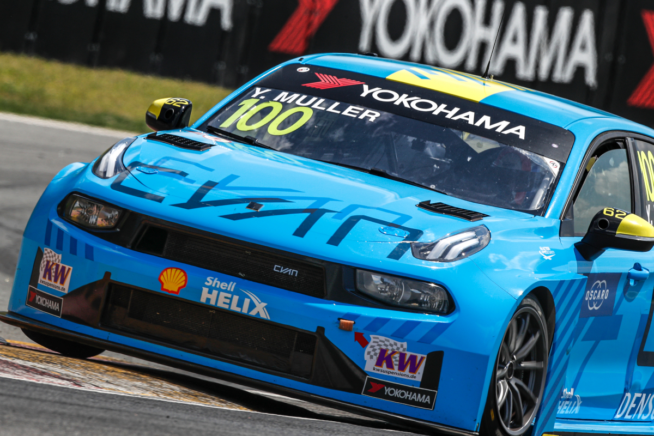

*Yvan Muller, Cyan Racing Lynk & Co, TCR, action during the 2019 FIA WTCR China, at Ningbo Photo Frederic Le Floc'h*

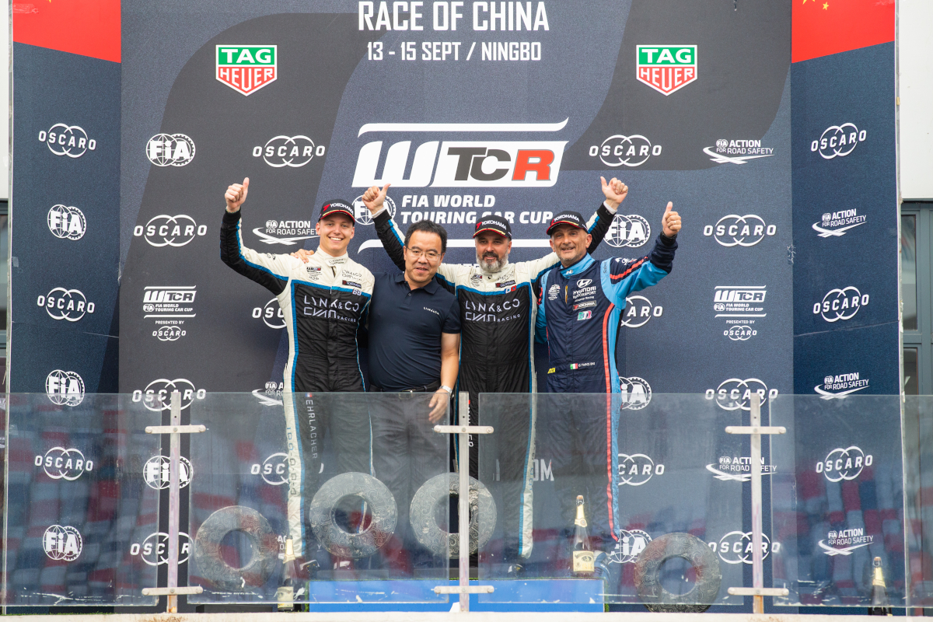

*Erlacher, Muller and Tarquini celebrate podium in WTCR China Photo Frederic Le Floc'h*